**Lab Exercise 7- Install Minikube on Linux (Ubuntu /MacOS/Windows)**

**Install Minikube on macOS**

brew install minikube

brew install kubectl

Start:

minikube start

**OUTPUT :-** 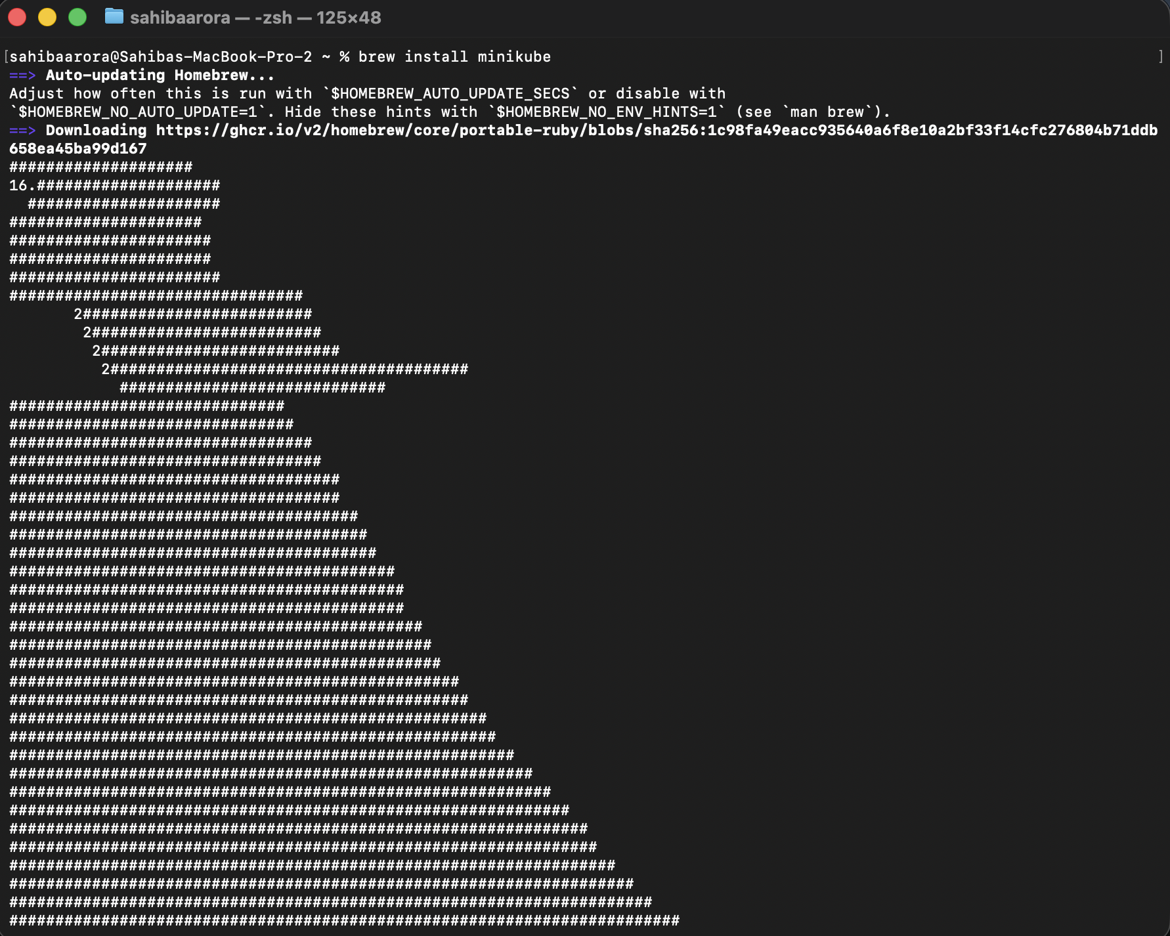

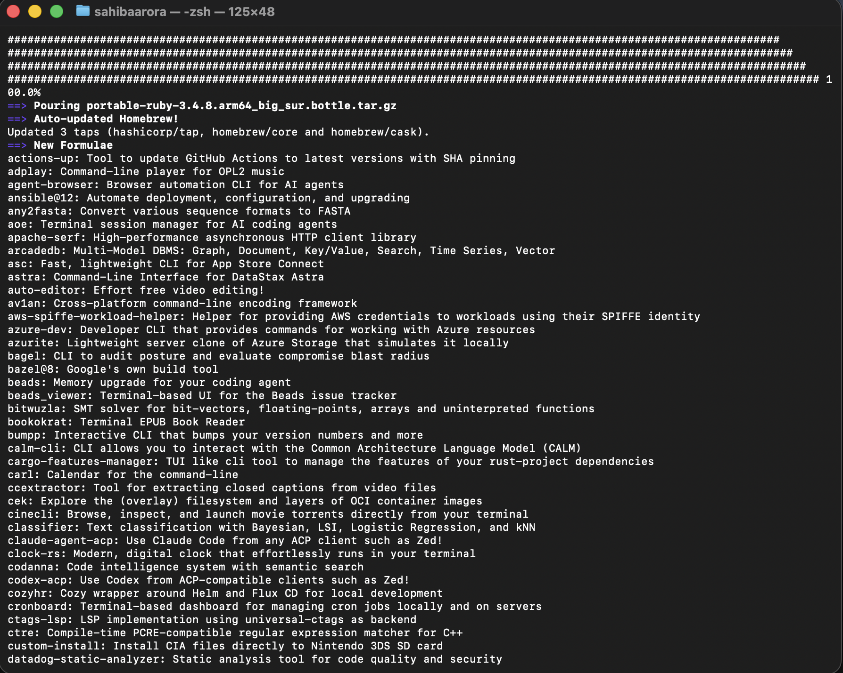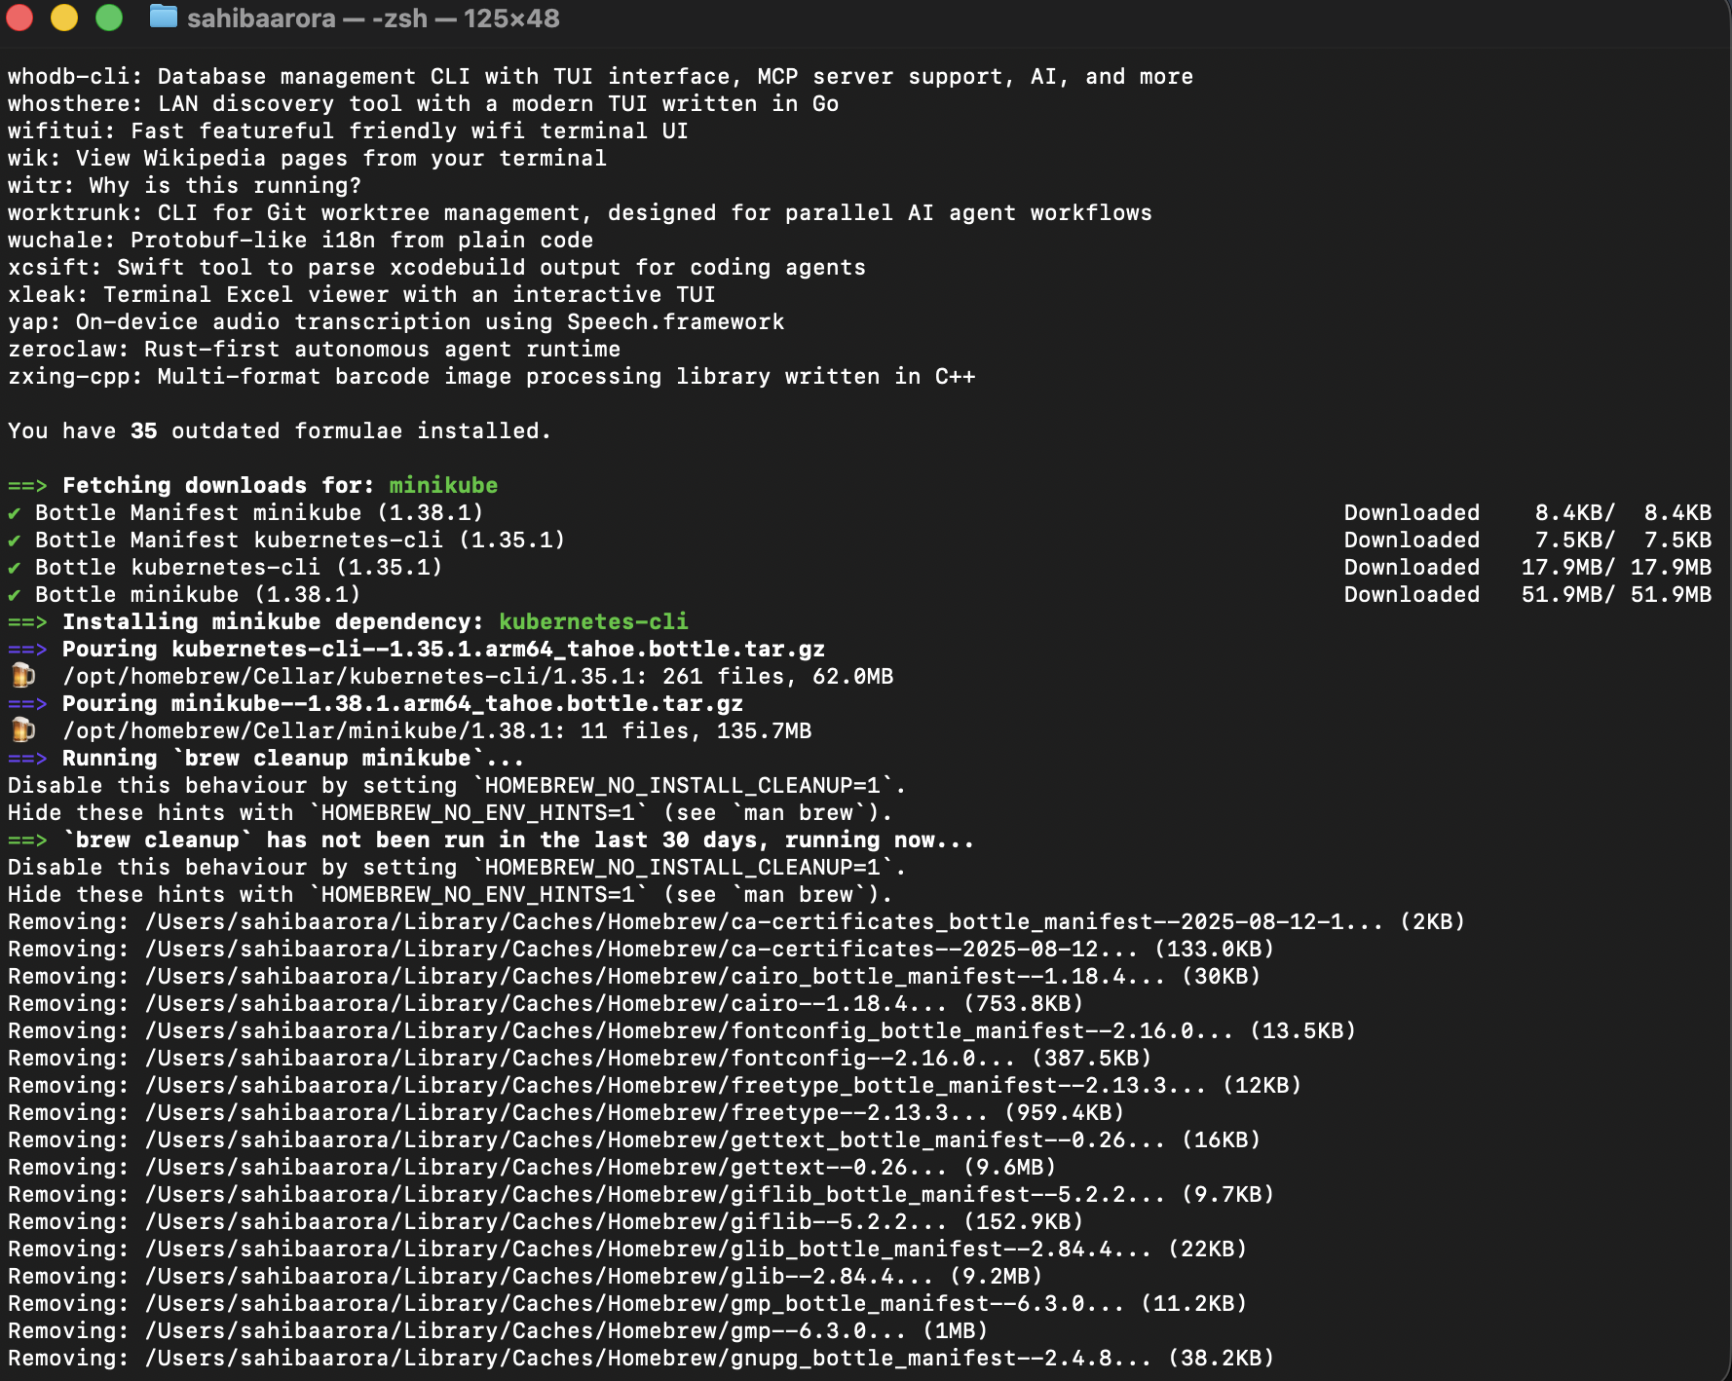

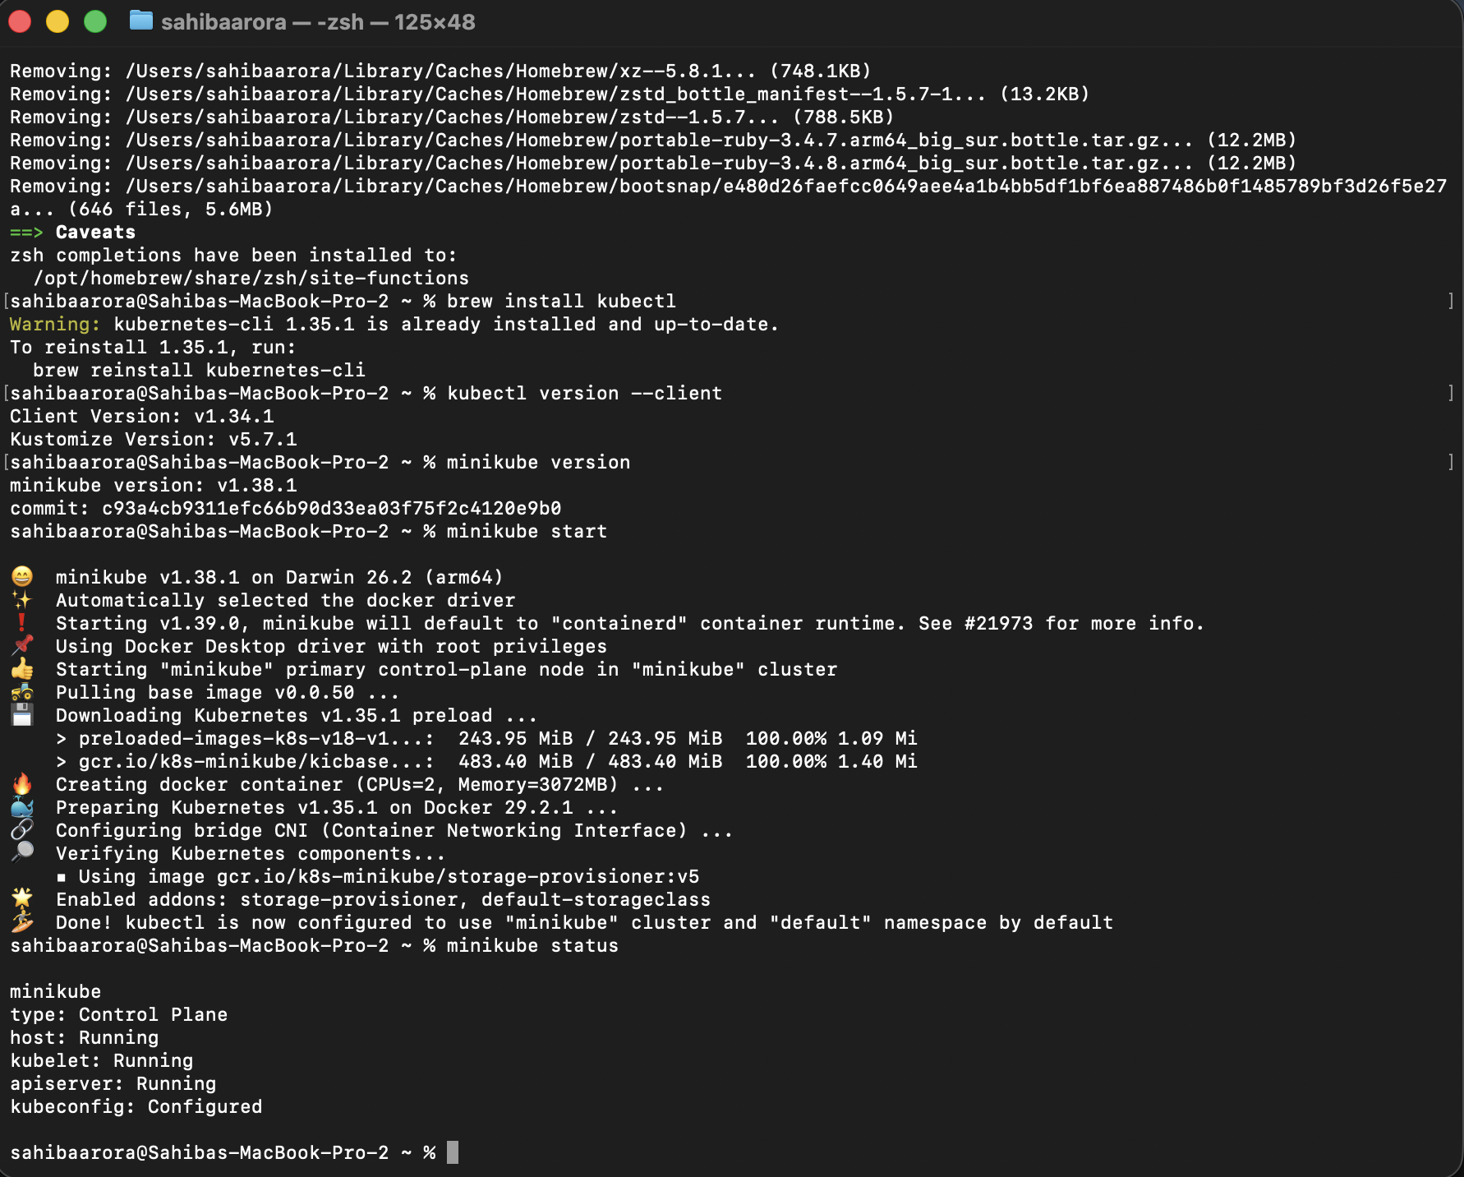

**Verify Kubernetes Cluster**

kubectl get nodes

Expected output:

NAME STATUS ROLES AGE VERSION

minikube Ready control-plane xx v1.xx

**OUTPUT :-**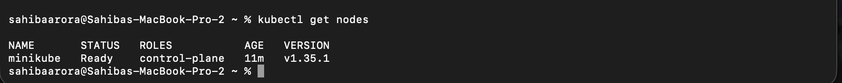

**Useful Minikube Commands (Lab Ready)**

| **Command** | **Purpose** |
| --- | --- |
| minikube dashboard | Open K8s UI |
| minikube stop | Stop cluster |
| minikube delete | Delete cluster |
| minikube ssh | Access node |
| kubectl get pods -A | View all pods |